Power of Togetherness (CPU + GPU)

Anusha

Paf-Kiet (karachi institute of economics and technology)
Karachi, Pakistan
anushaumatiya@gmail.com
Tabish
Paf-Kiet (karachi institute of economics and technology)
Karachi, Pakistan
tabish.momin.14@gmail.com

Muhammad Haseeb
Paf-Kiet (karachi institute of economics and technology)
Karachi, Pakistan
haseebhannan1q2@gmail.com

Abstract
This document includes the concept of augmenting OS kernel with GPU to enhance computing power of CPU. GPU can be more beneficial to us than just doing Graphical processing. Combined both can bring new opportunities of computing. Despite their increased computational power and range of applications the security implications of GPU’s Have not been carefully studied. They are used as co-processor that has separate memory space, has minimal support of multi-user programming, and constrained I/O abilities inherently ensures security. we present a prototype GPU a co-processor helping OS kernel along with Symmetric and Asymmetric cryptographic component AES and RSA also GPU’s vulnerabilities regarding Security.

Introduction
When computers were invented CPU’s were the center of focus even after decades nothing changed CPU’s and its performance were solely the center of attention. As world evolved technological advancement also took place and Gradually CPU’s lacked power and could no longer keep up with the projection of Moore’s law [1] that states “Processor speeds, or overall processing power for computers will double every two years”. To keep CPU’s power in balance and to get a better performance gain, manufactures were forced to utilize more power through parallelism technique. [2] GPU’s primarily were used to accelerate graphical display and not much else but none had than thought of combining these two would give an outstanding result, Background of GPU connecting with CPU was Before GPUs introduce computer works on vertices to pixels that transforms done on CPU. Compute each pixel “by Hand”, in slow.
CPU+GPU parallelism came out to be a successful experiment because GPU performance has doubled more frequently outpacing even the predictions of Moore's law. They enhanced an immense power in CPU’s through it. [2] The OS kernel desires a brand-new framework if it's miles to take benefit of the possibilities presented by means of GPU’s. To demonstrate the feasibility of this idea, they have designed and prototyped KGPU, a framework for calling GPU code from the Linux kernel. Next step was to explore if GPU’s are powerful enough to help in information security or not. To understand security of GPU’s [3] we require full knowledge and understanding of its hardware and software components that is its stack, chipsets, associated busses that manages a platform’s transfer of data, memory system known as “pixel Vault” but previously flaws were found in pixel Vault’s GPU security model, there were few attacks on model NVIDIA GPU that reads secrets from CPU memory and corrupts the memory state of CPU computations by leveraging GPU Direct Memory Access (DMA) capabilities which proved GPU security model stem from the lack of a clear software/hardware boundary and shifting responsibilities of hardware and software across GPU generations.

Literature Review
There were basic and foremost important tasks planned for parallelism of GPUS working with Kernel/CPUS [2] for improvement of Operating system’s Performance, Efficiency, Functionality and Security. As increased focus on GPUS help because of their cost-effective behavior.
1) To reduce tasks which are executed repeatedly and quickly on GPUs than on CPUs (Saving space) while Speeding Executions
2) To increase output for operations like huge number of client server handlings
3) To make compatibility of advance functionalities in OS Kernel that are too slow while running on CPU.

Networking with GPU
According to [4] Packet-Shader was the first one to demonstrate GPU’s real potentials regarding network packet processing. As Shader forwards IPv4 packets at rate 40Gbps and GPU brought a vivacious improvement for both memory and compute-intensive applications; IPv6 forwarding reaches 38.2 Gbps for 64B packets and the IPsec performance ranges from 10 to 20 Gbps. GPUs’ enormous parallel processing power opened an incredible opportunity for high-performance software routers with cost effectiveness and full programmability. [5] NVIDIA GPU GTX480 has software suite of libraries and compiler named CUDA (Compute Unified Device Architecture), for other GPU functionalities an API is also provided by it.

GPGPU
The concept of GPGPU (General-Purpose Computation using GPU) has ascended in recent years. [5]GPGPU applications make use of GPUs as massively parallel processors, turned away from their original purpose but nonetheless highly efficient in numerous application domains. Combining both speed and bandwidth due to their parallel architecture (and accessible cost), GPUs are an attractive choice for complex computations compared to traditional CPUs since they exhibit significant performance overheads, and are supported by constantly improving high-level programming language provided by both GPU vendors and the academic community. GPUs have now evolved from highly-specialized graphics processors into powerful, flexible programmable units, and become increasingly popular for a wide range of applications[6],[7]. Signal, Image and Video Processing also found demanding to implement that GPGPU Segmentation techniques were also introduced.
The GPU accelerate regular expression matching, with speedups of up to 48 times compared with CPU. A network intrusion detection system (NIDS) with GPU-accelerated regular expression matching a very incontestable fairly 60% increase in overall packet process output on an old GPU hardware.
Different tasks like information flow, controls within the OS, virus detection (with 2 orders of magnitude speedup), rule-based firewalls, and content-based search in filesystems will doubtless profit from GPU-accelerated pattern matching.

In- Kernel Cryptography
GPUS are best at speeding up computations faster than CPUS. To utilize them in Block cryptography DES or AES lot of computations are required this is covered below in AES Example that proposed KGPU implements AES on the GPU for the Linux Kernel (Section IV). blocks of information will represent either giant blocks of one task or variety of smaller blocks of various tasks. but Thus, the GPU can't solely speed up bulk encoding however additionally re-scale the quantity of synchronic users of the cryptography scheme, [2] OS practicality creating significant use of cryptography includes IPSec. File system encryption, and content-based information redundancy reduction of filesystem blocks and memory pages. Another potential application of the GPU-accelerated cryptography is trusted computing supported the trusty Platform Module (TPM). A TPM is basically hardware with software implementations of the TPM specification, such as vTPM, are developed for hypervisors to provide trusted computing in virtualized environments where virtual machines cannot access the host TPM directly. The kernel of Linux holds a general-purpose cryptographic library used by many of its subsystems. This library can easily be extended to divest the GPU.

KGPU Architecture

Cryptography
[8] AES is now currently being used as the standard block cipher algorithm which has replace the Data Encryption Standards (DES). In 1997 National Institute of Standards and Technology announced for anew cipher algorithms which could replace the DES. An overview summary
of the requirements made by the NIST for the AES are as follows:

- Symmetric-key cipher
- Block cipher
- Support for 128-bit block sizes
- Support for 128-, 192-, and 256-bit key lengths
In October 2000, the Rijndel Algorithm was chosen as the new standard encryption algorithm. The operation of the AES algorithm is shown in the below flow chart. The steps of encryption use a key which converts which convert the input data into an unreadable text (Cipher Text). In the decryption the same key which was used in the encryption is used to convert the cipher text into its original form.
Plaintext 00112233445566778899aabbccddeeff

Encryption:
Key 000102030405060708090a0b0c0d0e0f

Cipher text 69a2ff1d9df52d1cv1d3f68dcd1c84a1

Decryption:
Key 000102030405060708090a0b0c0d0e0f

Plaintext 00112233445566778899aabbccddeeff

The process of encryption and decryption is quite simple but some of the detailed cryptographic is required to understand what is happening in the whole process. Algorithms such as AES are called product ciphers. For such type of ciphers encryption is done in rounds, in which each round processing is done using the same logic. Furthermore, many of these ciphers including the AES can change the key use in the encryption at each round. The strength of encryption done by the product cipher can be improved by increasing the number of rounds used to process the data. AES standard determines that the number of rounds is specified by the length of the cipher key, shown below:

Key Length | Number Of Rounds
128 | 10
192 | 12
254 | 14

Example: AES Implementation On GPU
As we have seen how the encryption and decryption of AES occurs. Now, let’s see how its implementation looks like in as a vertex program.

Working:

!!NVvp4.0
/*
* aes.vpt -- AES encryption and decryption
* Author Yamanouchi_Takeshi@sega.co.jp
*/
// input, output
ATTRIB state_in = vertex.attrib[0];
OUTPUT state_out = result.texcoord[0];
// macros
INT TEMP _tmp0, _tmp1; // macro work
#define ROT8(_arg) \
SHL.U _tmp0, _arg, 8; \
SHR.U _arg, _arg, 24; \
OR _arg, _arg, _tmp0

Here we have expanded the cipher key by using the CPU and storing the GPU program local parameter.

Program Input/output and The State:

[8] The AES encryption works over a two-dimensional array of bytes which is called ‘The State’. We have divided our data into 16 bytes of sequential blocks and unpacked it into 4x4 arrays that we had pushed into the GPU’s register. During the output step, we have packed the 4x4 array back into sequential block of 16 bytes as shown in the Figure below:

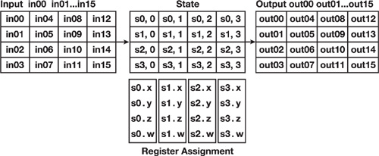

In the initialization stage, we have done an AddroundKey Operation which is also a XOR operation on the state by the round key. In our case we have performed unpacking and round key addition together. The round for AES operation consists of four operations:

SubBytes Operation

ShiftRows Operation

MixColumns operation

AddRoundKey operation

SubBytes Operation;

This operation substitutes bytes independently by using a nonlinear substitution table called the S-Box table, shown blow:

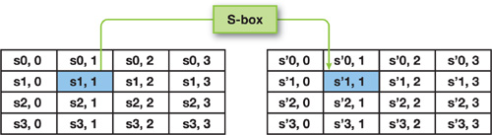

ShiftRow Operation:

This operation shifts the last three rows of the state cyclically:

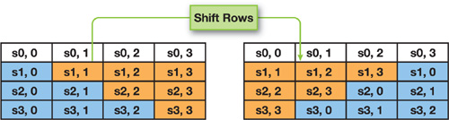

MixColumn Operation:

The Mixcolumn operation has the purpose of
contending the data of every column. A matrix multiplication is performed on every column to run this operation.

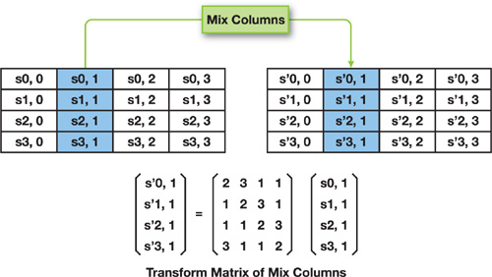

AddRoundKey Operation:

It actuates the current round key from the key schedule, where the register serves as the argument.

Performance of the Cipher:

As we have known the working of the AES implementation lets measure its performance on GPU based encryption. We have omitted the decryption because it performs the same mechanism as the encryption does.
Our test was performed on the testing machine with the following specification:
- CPU: Pentium 4, 3 GHz, 2 MB Level 2 cache
- Memory: 1 GB
- Video: GeForce 8800 GTS 640 MB
- System: Linux 2.6, Driver 97.46

Comparison Between Vertex and Fragmented Program;

We have compared the performance of the Fragmented program in the rendering pipeline and the Vertex program in the feedback mode pipeline. The vertex and the fragment program are the same code except the input and output registers redefined properly, manipulating the GPU’s undivided architecture [9], [9]
Our result was achieved by processing 128 MB multiple times and performing ten races. As performance is set for vertical programs of 53 MB / sec, while for the per-part program, the performance size is 95 MB / sec for a size of 1 MB. Regarding our implementation, the maximum processing time spent on the table.

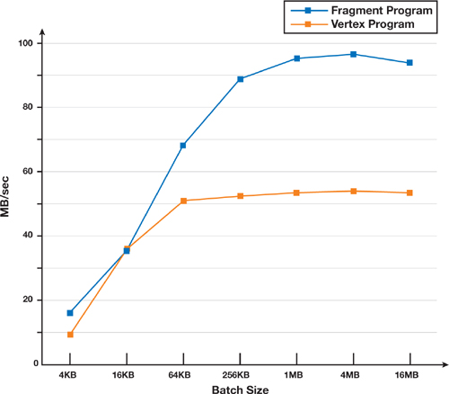

CPU Based Encryption Comparison;

We measured the speed of these CPU-based passwords on the same test machine and we obtained a result of approximately 55 MB / s using the same AES algorithm. Compared to the speed of CPU applications, our GPU-based encryption is approximately the same speed as the vertex program and about 1.7 times faster for the fragment program. The feedback conversion mode makes it easier to write code for data feeds, but it doesn't work for now.

References
- Robert R. Schaller. George Mason University. SCHALLER ~ MOORE'S LAW PAST, PRESENT, AND FUTURE.IEEE Spectrum June 1997
- Weibin Sun, Robert Ricci. University of Utah, School of Computing ~ Augmenting Operating Systems with the GPU. 15th May 2013
- Zhiting Zhu, Sangman Kim, Yuri Rozhanski, Yige Hu, Emmett Witchel,and Mark Silberstein. 2016. Understanding the Security of Discrete GPUs., Austin, TX, USA, February 04-05 2017.
- Sangjin Han, Keon Jang, KyoungSoo Park, Sue Moon.Department of Computer Science, KAIST, Korea. SIGCOMM’10, "Accelerating SSL with GPUs."August 30–September 3, 2010
- Jason Sanders,Edward Kandrot. Book: CUDA by Example: An Introduction to General-Purpose GPU Programming.
- John D. Owens, David Luebke, Naga Govindaraju, Mark Harris, Jens Krüger, Aaron E. Lefohn, and Timothy J. Purcell. A Survey of General-Purpose Computation on Graphics Hardware. Volume 26 (2007)
- Carlos Aguilar Melchor, Benoit Crespin, Philippe Gaborit, Vincent Jolivet,Pierre Rousseau. High-Speed Private Information Retrieval Computation on GPU. September 2008
- Verma, H.K. and Singh, R.K., 2012. Performance analysis of RC6, Twofish and Rijndael block cipher algorithms. International Journal of Computer Applications (0975–8887), 42(16), pp.1-7.
- Manavski, S.A., 2007. CUDA compatible GPU as an efficient hardware accelerator for AES cryptography. Signal Processing and Communications, 2007.
- Szerwinski, R. and Güneysu, T., 2008, August. Exploiting the power of GPUs for asymmetric cryptography. In International Workshop on Cryptographic Hardware and Embedded Systems (pp. 79-99). Springer, Berlin, Heidelberg.

